Healthy Eating Policy

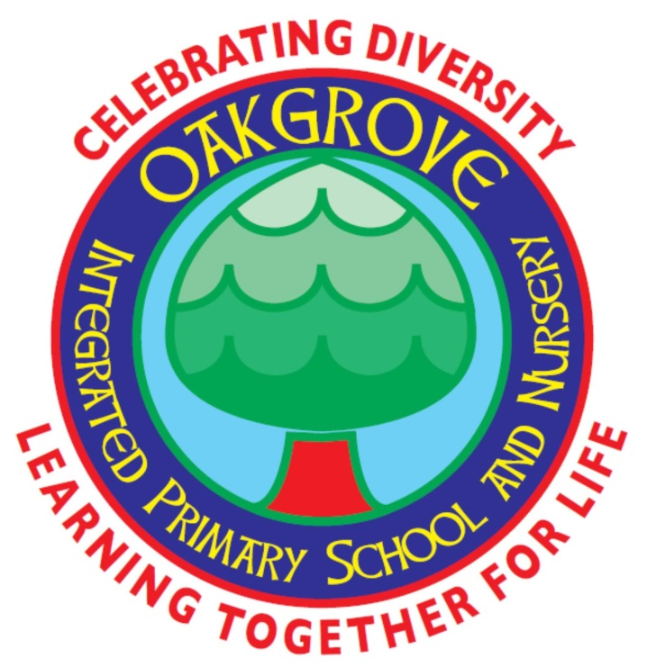

Oakgrove Integrated Primary School & Nursery

June 2022

Review Date: June 2026

Healthy Eating Policy

Oakgrove IPSN has adopted a Healthy Eating Policy in a response to concerns raised by children, staff and parents to the quality of the food eaten by children. It has been developed over a number of years with input from parents, staff, outside agencies and the children, (School Council).

Our policy promotes the following:

- Fizzy drinks are discouraged in school;

- Children are encouraged to drink water, fruit juice and milk;

- Water is encouraged throughout the school day, particularly during class;

- We encourage all to have a healthy break e.g fruit & veg (apples, oranges, cucumber sticks, carrots) crackers

- We participate in our “Healthy Eating Initiative”. (Free fruit for everyone every day for 4 weeks)

The benefits for our children and positive feedback we received from parents have encouraged us to continue implementing this scheme - we have less litter in our playground and increased appetites at lunchtime, which has greatly reduced food wastage. We now have pupils who routinely include a healthy snack in their diet.

We recommend our mid-morning break to be fruit, vegetables and water. The eating of other healthy foods e.g. cheese and yoghurts are also considered appropriate if the pupil prefers these to fruit or vegetables.

We can also have pupils in our school who have a severe food allergy to peanuts/nuts. It is important that there is strict avoidance of this food in order to prevent a life-threatening allergic reaction.
Examples of some types of foods that children should avoid bringing to school are listed below:

- Any type of nuts
- Fruit cereal bars containing nuts eg Tracker bars, Alpen bars etc. (check the wrapper for ALLERGY ADVICE)
- Nutella spread
- Peanut butter spread
- Bags of nuts
- Bags of fruit and nuts
- Coconut
- Chocolate eg Cadburys Fruit and Nut or Whole nut or Toblerone Fruit and Nut

Our school dinner menu is prepared by the EA catering staff and is in line with the Nutritional Standards. All children receive a copy of this menu and it rotates on a four week cycle.
Good food habits should be encouraged in children from an early age, as this is a time of rapid growth and development. There is growing concern throughout Northern Ireland about what our children are eating. Compared to recommended dietary guidelines, many children are consuming too much fat, sugar and salt and too little fibre.
Good nutrition is essential to:
- Allow children to reach their full potential
- Encourage healthy eating patterns from early on in life
- Protect against decaying of the teeth
- Prevent against long-term health problems, e.g. obesity, diabetes, coronary heart disease, osteoporosis and cancers

We as a school are working to promote healthy eating habits and improve oral health in children, through the implementation and maintenance of The Healthy Eating Initiative.
The Initiative suggests that at lunch time the children’s lunch boxes should consist of at least one healthy portion from each of the four main food groups listed below and children should be encouraged to reduce their daily fat, sugar and salt intake.
- Bread, Cereals and Potatoes
- Fruit and Vegetables
- Milk and Diary Foods
- Meat, fish and Alternatives

The School’s Board of Governors are committed to this challenge and we encourage our parents to support the school’s Healthy Eating policy by sending only healthy food to school with their children.
It is often difficult to provide a healthy lunch box that is appealing to the child. For the benefit of parents, we distribute a PHA booklet,”Healthy Choices” at Induction (P1) with a selection of ideas to aid in the preparation of a healthy lunch. Also included are tips on the safe preparation and storage of food in the lunch boxes.
With the continual rise in obesity throughout our community, we feel our children will greatly benefit from eating healthy.

Other initiatives promoted by this policy include:
- Terms 1-3 – we operate a Breakfast Club.

- Healthy Tuck shop term 3

- Primary 1 to Primary 3 are encouraged to bring in their own fruit to share. Primary 4 to Primary 7 are encouraged to bring in their own fruit.

C. Lally
Health & Wellbeing Co-ordinator June 2022

Contributions from School Council

